2017 Taiwan Thailand Auto Manufacturer Event
Date & Location
Meeting date:
Friday, November 24, 2017
Location:
Maple Hotel Bangkok (7.7 km from BITEC, 13 min by car )
Address:
9 Srinakarin Rd., Bangna Rd., Bangrak, 10250 Thailand

Agenda - November 24, 2017
Time | 2017 Taiwan Thailand Auto Manufacturer Event
13:30-14:00 | Registration
14:00-14:05 | Welcome speech
14:05-14:15 | Thailand TAPMA opening speech
14:15-14:30 | ”Taipei Economic and Culture Office in Thailand” opening speech
14:30-14:35 | Introduction: Tongtai Machine & Tool Co., LTD
14:35-14:55 | Intelligent machining solutions in the age of producing automotive precision components
14:55-15:00 | Thai summary
15:00-15:05 | Introduction: SHIEH YIH Machinery Industry Co., LTD
15:05-15:25 | Increasing production efficiency by applying comprehensive smart press line
15:25-15:30 | Thai summary
15:30-15:35 | Introduction: Jainnher Machine Co., LTD
15:35-15:55 | Versatile automated grinding systems that achieves quality consistency and automotive mass-production
15:55-16:00 | Thai summary
16:00-18:00 | Cocktail Party

Extra Benefits with the special gifts - Sony EXTRA BASS™ Sports In-ear Headphones – 20 In-ear Headphones we will prepare to appreciate your support for our event, First register, First Get!!!

Route Direction:
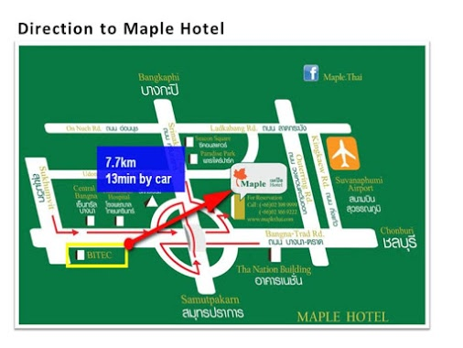
Register
Company name:

Department name:

Your name:

Your position:

Your phone number:

Your E-mail address:

Thank you for kindly answering all the questions above, we are looking forward to seeing at the conference!

