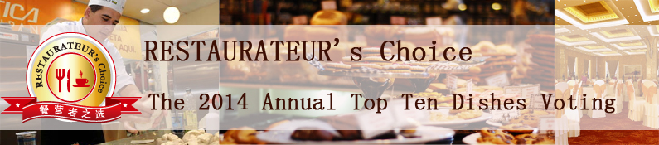

The 2014 Annual Top Ten Dishes
Nomination Form

To be nominated:
- The nominated recipes must be used in F&B industry.
- Please complete all fields in this form and attach extra dishes picture/marketing report so that the judges get adequate information about your recipe in the best possible manner.
- Please submit the nomination form to katherine@ringiertrade.com before August 20, 2014.
- In case of any query regarding nomination form, kindly contact: katherine@ringiertrade.com

Part Ⅰ- Company Profile
Restaurant Name
(in English)
Restaurant Name
(in Chinese)
Address (please indicate Zip)
Tel (please indicate area code) |  | Fax (please indicate area code)
Company Email |  | Website
Part Ⅱ- Contact Info
Contact Name |  | Title
Tel (please indicate area code) |  | Email
Part Ⅲ- Product Details
Name of the Recipe Nominated (in English)
Name of the recipe Nominated (in Chinese)

Product Profile
(Max: 500 words, please send high-resolution pictures as an attachment)
Restaurant Profile
(Max: 300 words)

